* Konda Ramsaikranthi Kirankumar Reddy
  + 18AK1A0471, 3rd year, 2nd section.
  + ECE department, AITS-Tirupati.
* M Sandhya
  + 18AK1A0471, 3rd year, 2nd section.
  + ECE department, AITS-Tirupati.
* Siva Kumar Sai Tharun
  + 18AK1A0479, 3rd year, 2nd section.
  + ECE department, AITS-Tirupati.
* P Satish
  + 18AK1A0484, 3rd year, 2nd section.
  + ECE department, AITS-Tirupati.

**INDEX**

1. **INTRODUCTION**
2. **PROJECT OUTLINE**
3. **HARDWARE COMPONENTS**
4. **SOFTWARE IMPLEMENTATION**
5. **BLYNK APP SETUP**
6. **GOOGLE ASSISTANT**

Introduction

**T**he main aim of this project is control home appliance over the internet. The main concept used in this project is ***IOT*** which means Internet of Things. Now a day the entire world is connected to the internet and made our life more comfortable. Everything is getting connected to the internet. In the past few decades the usage of internet has rapidly increased. So to make our life more comfortable we are going to connect the home appliance to internet and control them over the internet with real time feedback.

To control any object over the internet we need to use a microcontroller which acts a barrier between the object and internet. We have various type of microcontroller such as ARDUNIO, Nodemcu ESP32, etc. But for this project we are going to use NODEMCU ESP8266 as a microcontroller which comes with integrated WIFI and BLUETOOTH modules, which makes connectivity easy to the internet and it has enough GPIO’s to attach as many as appliance to it.

In this project we are going to introduce, how to control four electronic appliance over the internet and manually with real time feedback. Not only that we have included one sensor to get some feedback when some enter your home by using the IR sensor. We used BLYNK app to control the appliance and then we linked our BLYNK app to the Google assistant by using a third party platform such as IFTTT, Zapier etc.

The upcoming generation will use the concept of IOT for various purposes. Which makes life more comfortable and the technology is also going in that path only. Our project can be taken to a great extent. Not only in the home we can use this concept in industries for controlling the manufacturing part and for monitoring the company. In banks it can be used for security purpose and in vehicles we can use this concept as a tracker or GPS tracker.

Project Outline

The following figure will show the outline of the project, how it will interact with each modules and how messages are sent over the other.

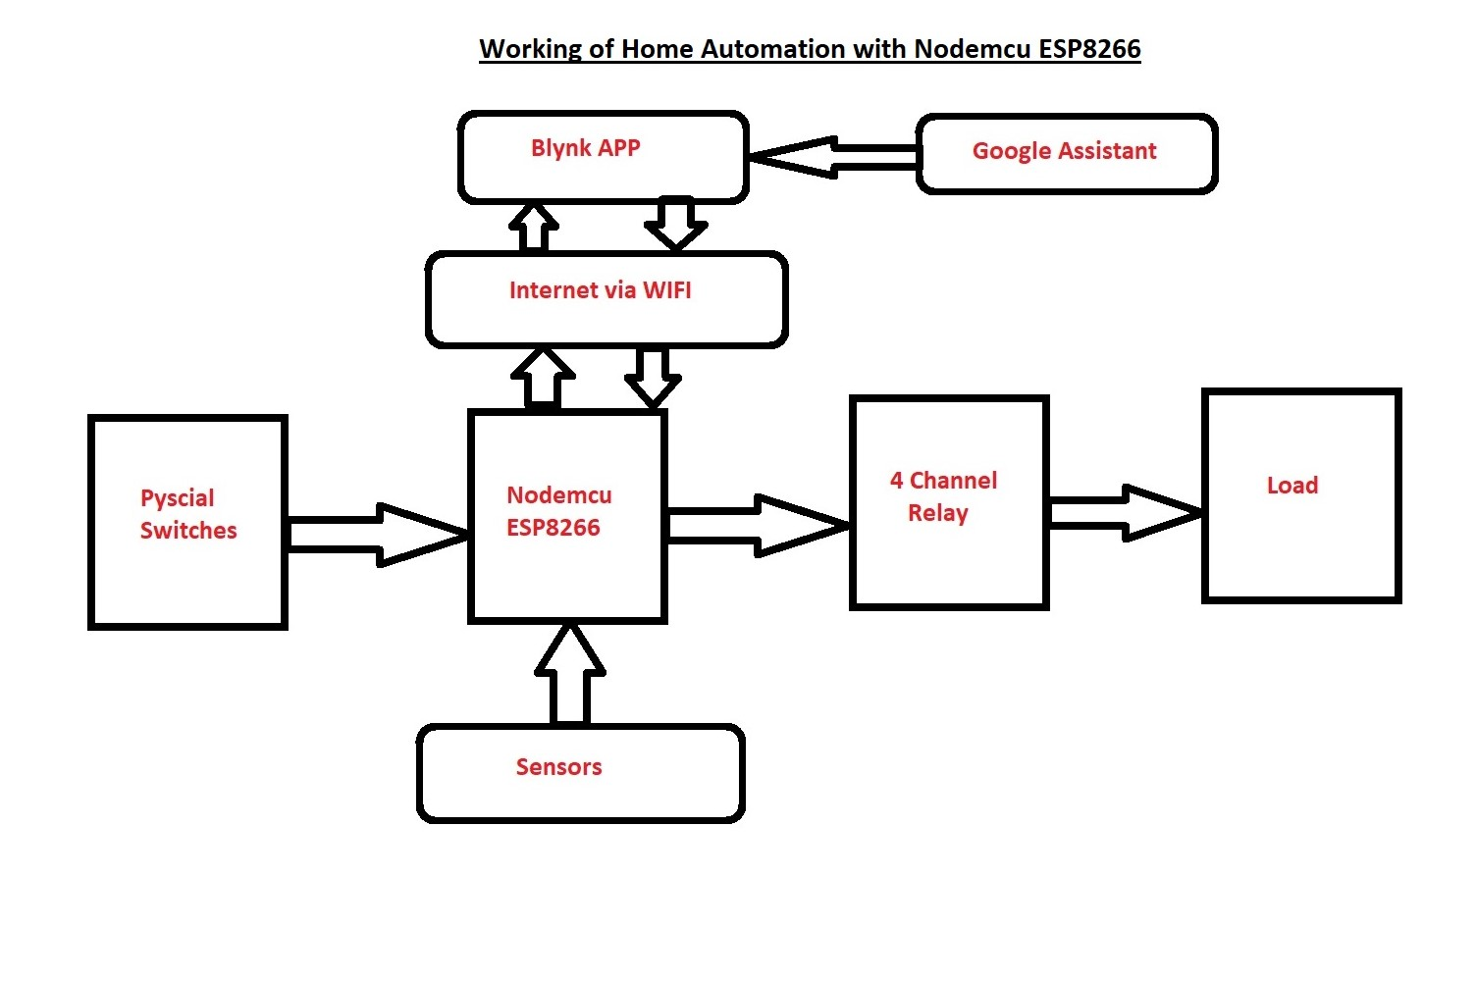

From the figure, it is clear that Nodemcu ESP8266 plays an important role in controlling the devices. When we press a physical button it will send that message to the nodemcu and it will change the status of the relay and these on feedback will be sent to the BLYNK app if it is connected to the internet. In this way when we press physical buttons also we can change the status of the relay.

In similar manner when we send a message through the blynk app to nodemcu then we can change the status of the relay board and control the relay board. By using Google assistant we can control the blynk and with that blynk app we can control the relay board. Sensors can be used to get the surrounding conditions.

HARDWARE COMPONENTS

|  |  |
| --- | --- |
| 1.Nodemcu ESP8266 | 6.Jumpers |
| 2. 4 Channel Relay board | 7.Push Buttons |
| 3.IR sensor | 8.9v Battery |
| 4. Alarm | 9. USB cable |
| 5. Bread board | 10. PC (for coding) |

Nodemcu ESP8266:

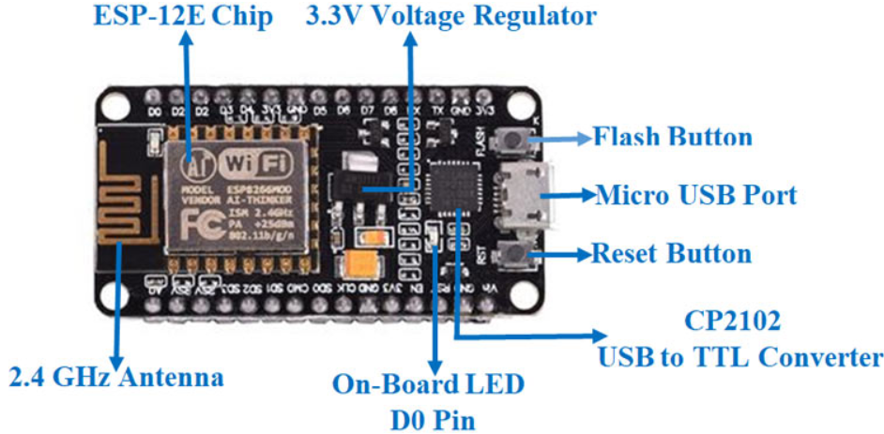

The **NodeMCU ESP8266 development board** comes with the ESP-12E module containing ESP8266 chip having Ten silica Xtensa 32-bit LX106 RISC microprocessor. This microprocessor supports RTOS and operates at 80MHz to 160 MHz adjustable clock frequency. NodeMCU has 128 KB RAM and 4MB of Flash memory to store data and programs. Its high processing power with in-built Wi-Fi / Bluetooth and Deep Sleep Operating features make it ideal for IoT projects.

NodeMCU can be powered using Micro USB jack and VIN pin (External Supply Pin). It supports UART, SPI, and I2C interface.

**NodeMCU ESP8266 Specifications & Features**

* Microcontroller: Tensilica 32-bit RISC CPU Xtensa LX106
* Operating Voltage: 3.3V
* Input Voltage: 7-12V
* Digital I/O Pins (DIO): 16
* Analog Input Pins (ADC): 1
* UARTs: 1
* SPIs: 1
* I2Cs: 1
* Flash Memory: 4 MB
* SRAM: 64 KB
* Clock Speed: 80 MHz
* USB-TTL based on CP2102 is included onboard, Enabling Plug n Play
* PCB Antenna
* Small Sized module to fit smartly inside your IoT projects

4 channel relay board

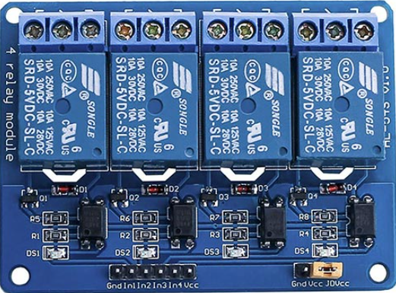

The 4 Channel Relay Module is a convenient board which can be used to control high voltage, high current load such as motor, solenoid valves, lamps and AC load. It is designed to interface with microcontroller such as Arduino, PIC and etc. The relays terminal (COM, NO and NC) is being brought out with screw terminal. It also comes with a LED to indicate the status of relay.

###### **Specification:**

* Digital output controllable
* Compatible with any 5V microcontroller such as Arduino.
* Rated through-current: 10A (NO) 5A (NC)
* Control signal: TTL level
* Max. switching voltage 250VAC/30VDC
* Max. switching current 10A
* Size: 76mm x 56mm x 17mm

IR SENSOR

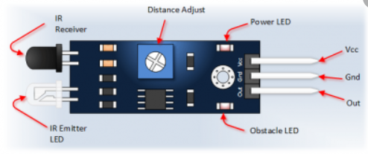

An infrared sensor emits and/or detects infrared radiation to sense its surroundings.

The basic concept of an Infrared Sensor which is used as Obstacle detector is to transmit an infrared signal, this infrared signal bounces from the surface of an object and the signal is received at the infrared receiver.

Principle of Working:

The principle of an IR sensor working as an Object Detection Sensor can be explained using the following figure. An IR sensor consists of an IR LED and an IR Photodiode; together they are called as Photo – Coupler or Opto – Coupler.

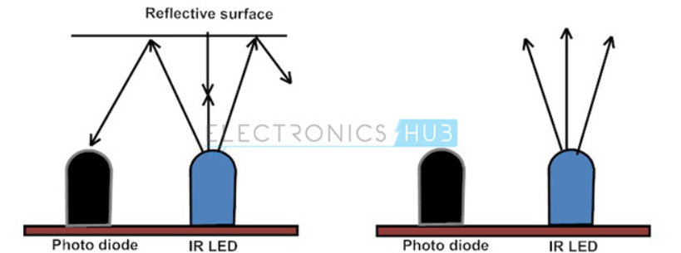

When the IR transmitter emits radiation, it reaches the object and some of the radiation reflects back to the IR receiver. Based on the intensity of the reception by the IR receiver, the output of the sensor is defined.

Hardware Connections

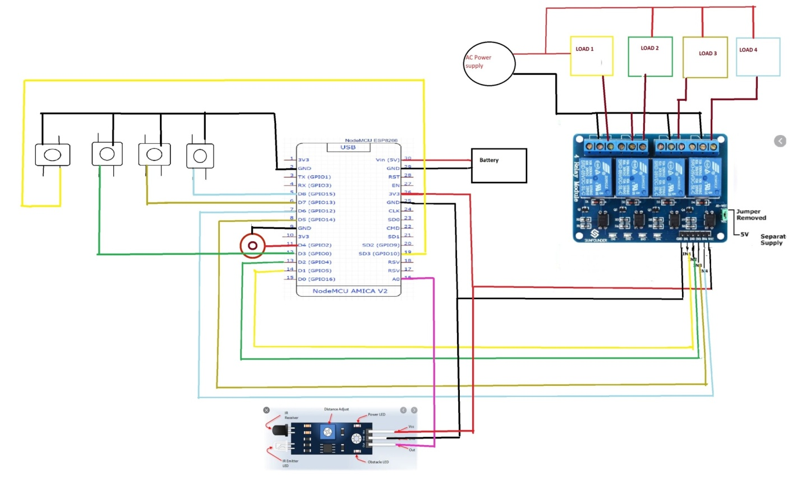

* The connections are given as per the circuit diagram.
* We can use either USB port to power NODEMCU or we can use a 9V battery to power the NODEMCU as shown in the figure.
* A speaker is attached to get a immediate sound when IR sensor detects a object.
* Connections of physical switches, relays to nodemcu the pin numbers are selected as follows: (v1,v2,v3,v4 are the virtual switches used in blynk app)

|  |  |  |
| --- | --- | --- |
| Physical switches | Relay pins | Blynk buttons |
| SD3 | D1 | V1 |
| D3 | D2 | V2 |
| D7 | D5 | V3 |
| RX | D6 | V4 |
| A0(IR sensor) | D4(Alarm) | ----- |

* A light glows on the IR sensor to indicate that it has got a good connection.
* A light gets ON on the NODEMCU board to indicate it is connected to the wifi .
* Don’t touch the front part of the 4 channel relay board because it deals with high voltages .

Caution: Be Careful while dealing with ac current.

Software implementation

* Download Arduino software for your PC using the official website <https://www.arduino.cc/en/software/>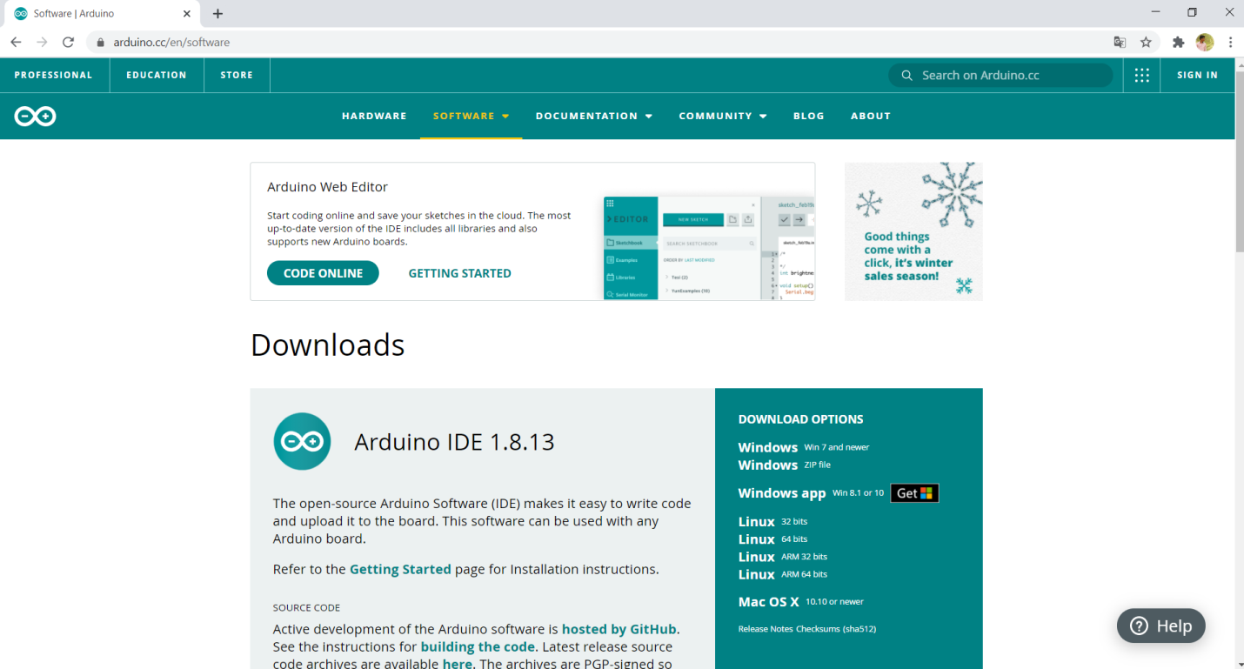
* Download the software as per your PC configuration and install it in your PC.
* To get nodemcu ESP8266 board configurations in the arduino software, add the following link in the preference.[**https://arduino.esp8266.com/stable/package_esp8266com_index.json**](https://arduino.esp8266.com/stable/package_esp8266com_index.json)

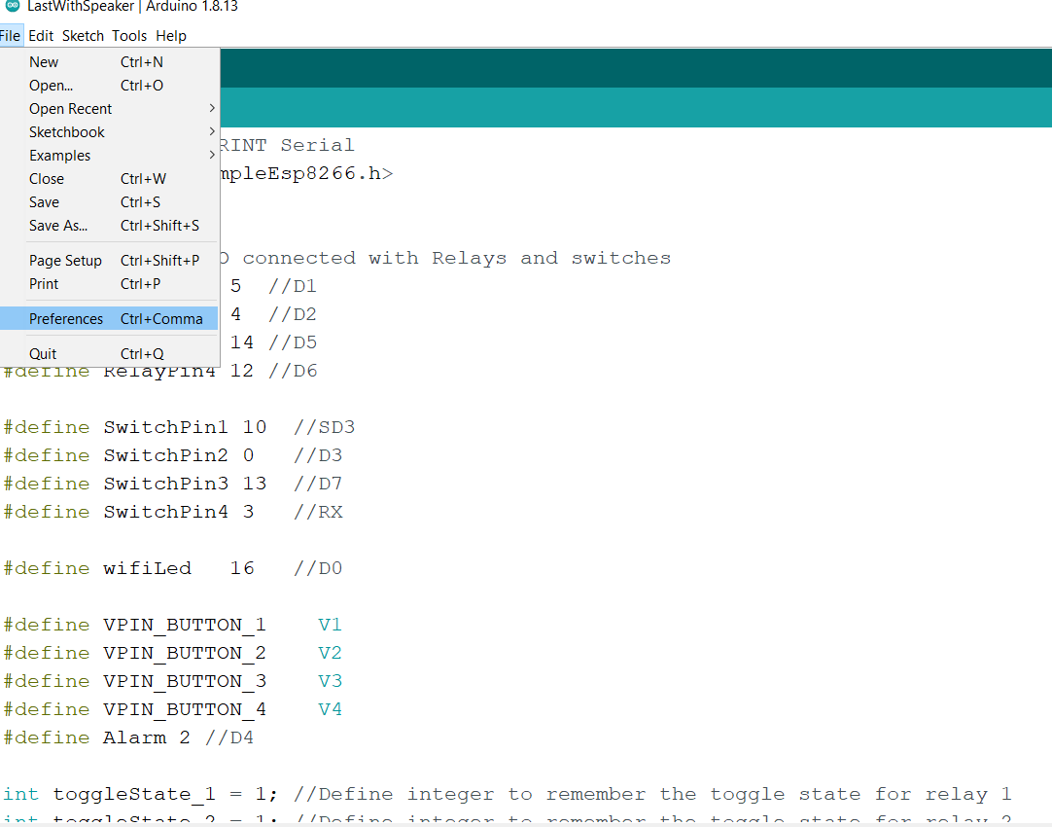

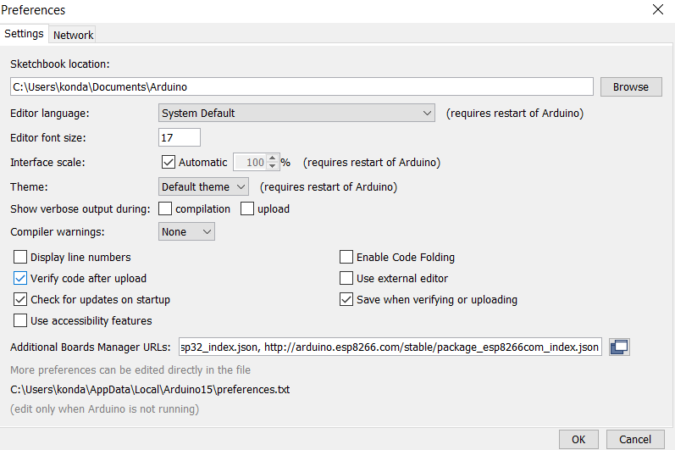

* In the board manager search for the esp8266 and install it.

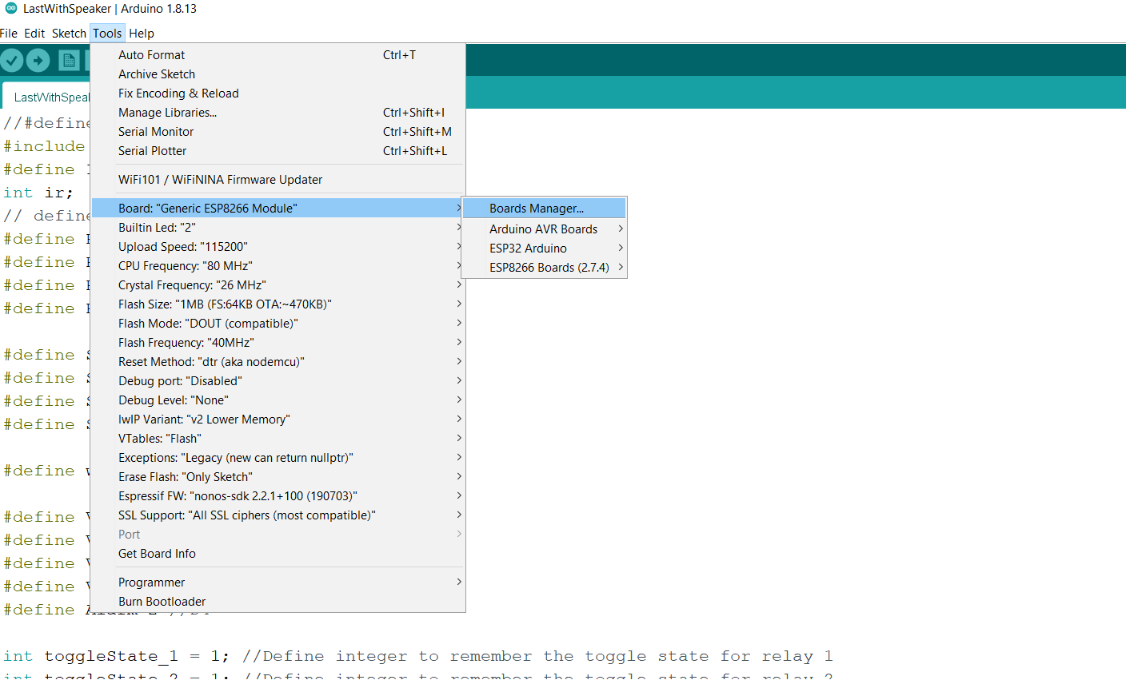

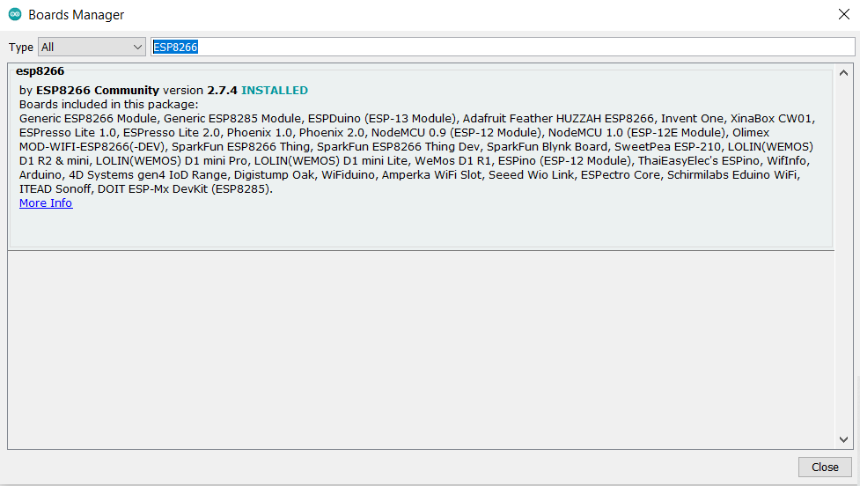

* Now select the code file that is provided in the folder. Open the file and provide your WIFI SSID and WIFI password along with AUTH code that we will get from the BLYNK app.

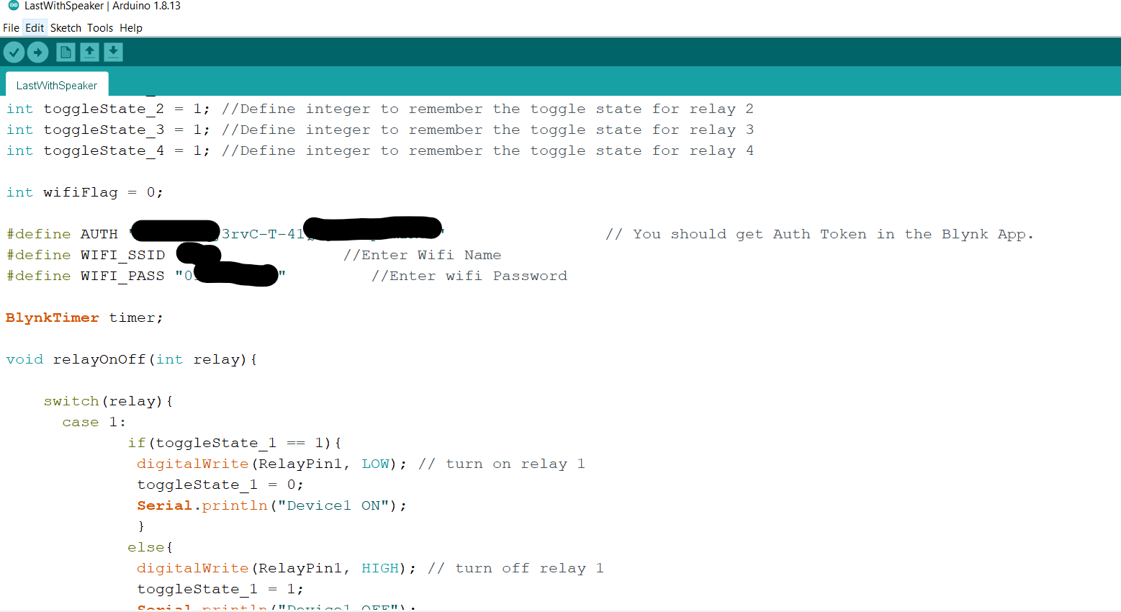

* Now connect the Nodemcu using USB port and select the COM port in ardunio software and click on upload button to upload the code into Nodemcu.

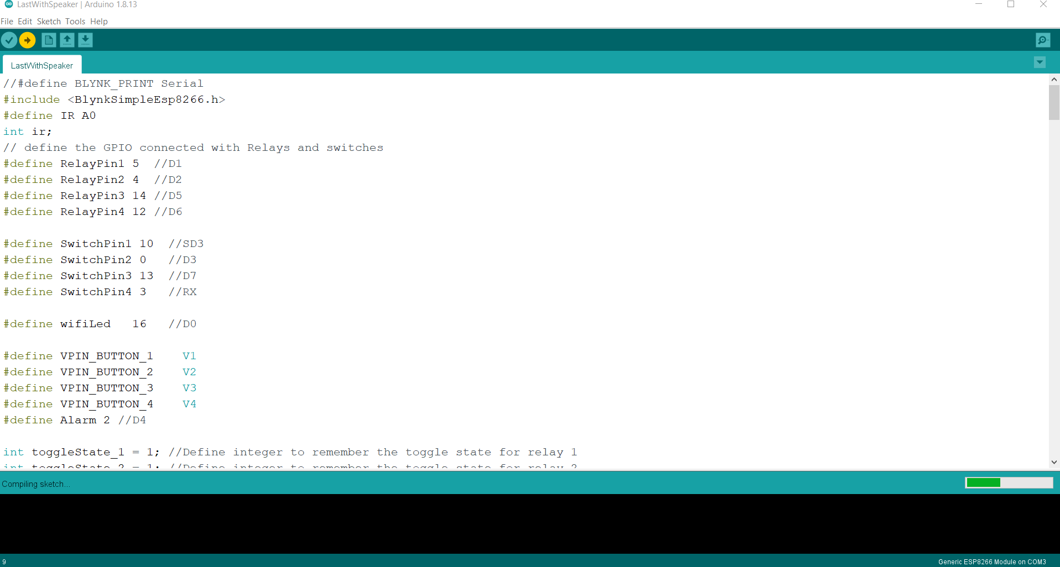

* Now the nodemcu will connect to the WIFI that your provided .

**NOTE: Don’t upload the code until you get the AUTH TOKEN from the BLYNK app.**

**BLYNK APP SETUP**

* **I**nstall blynk app in your mobile from play store.

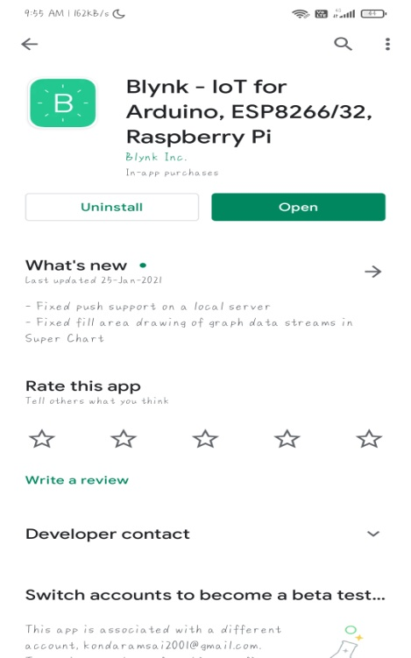

* Signup in the Blynk app using your mail id(This mail id will be used in the future).

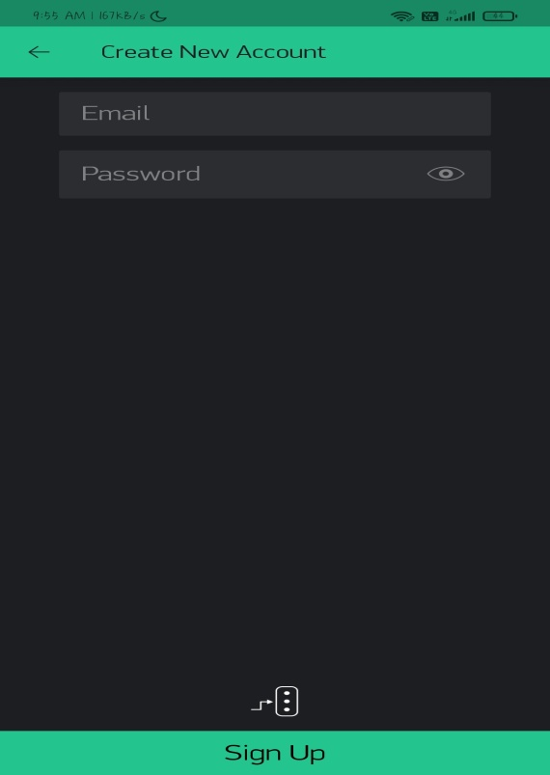

* Click on new project, name the project and select the appropriate board and click on create button as shown below.

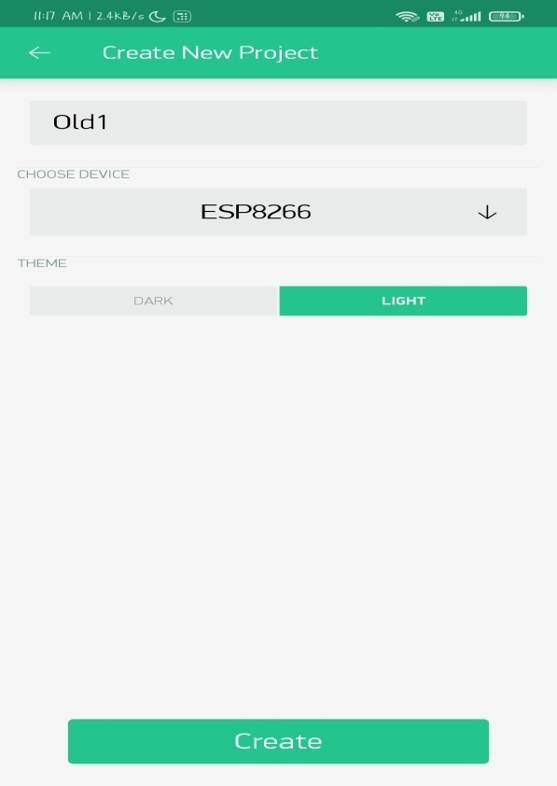

* After creating project, click on the setting button to to get your AUTH TOKEN which we need to use to code the board.(You can send mail or you can copy AUTH token) as shown in the below figure.

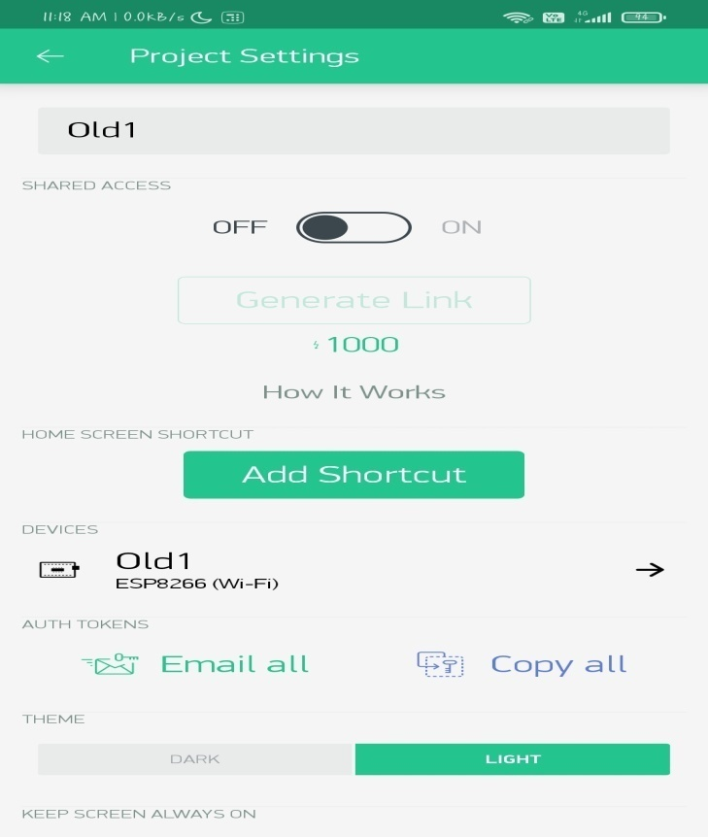

* Click on the plus button to add Virtual switches to your Blynk app as shown in the figure.

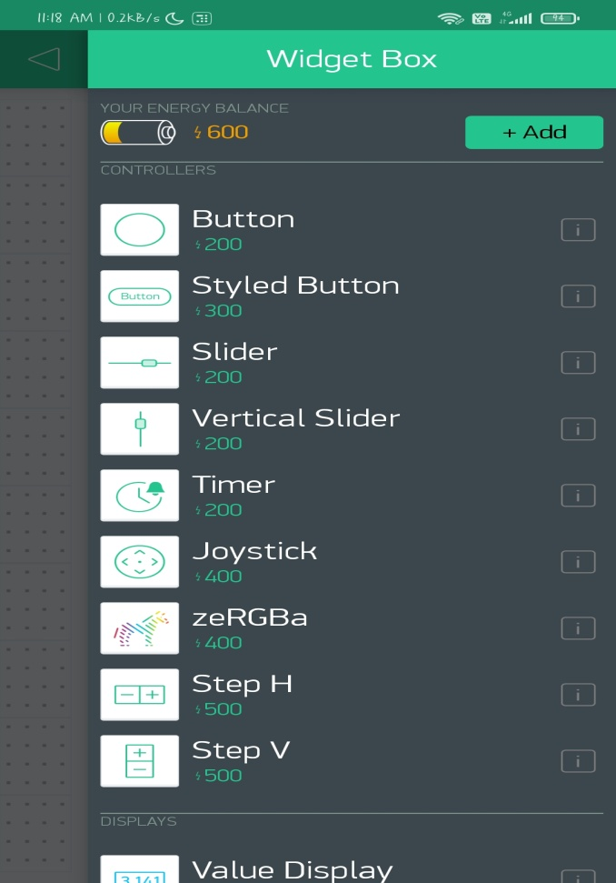

* Configure the button to virtual switches and select the virtual pin numbers as shown in the figure.

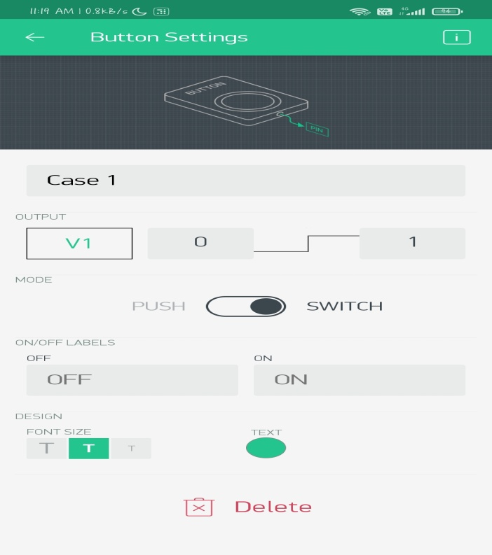

* Add four virtual pins (v1,v2,v3,v4) and a notification button to get feedback for IR sensor as shown in the figure.

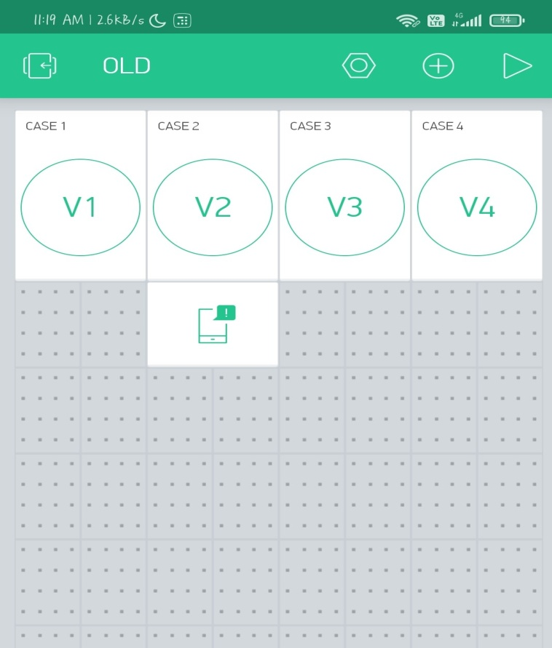

* Now your Blynk app is ready . Now connect your nodemcu to internet and click on play button in blynk app , then the app will appear in this manner, if nodemcu is connected to the internet.

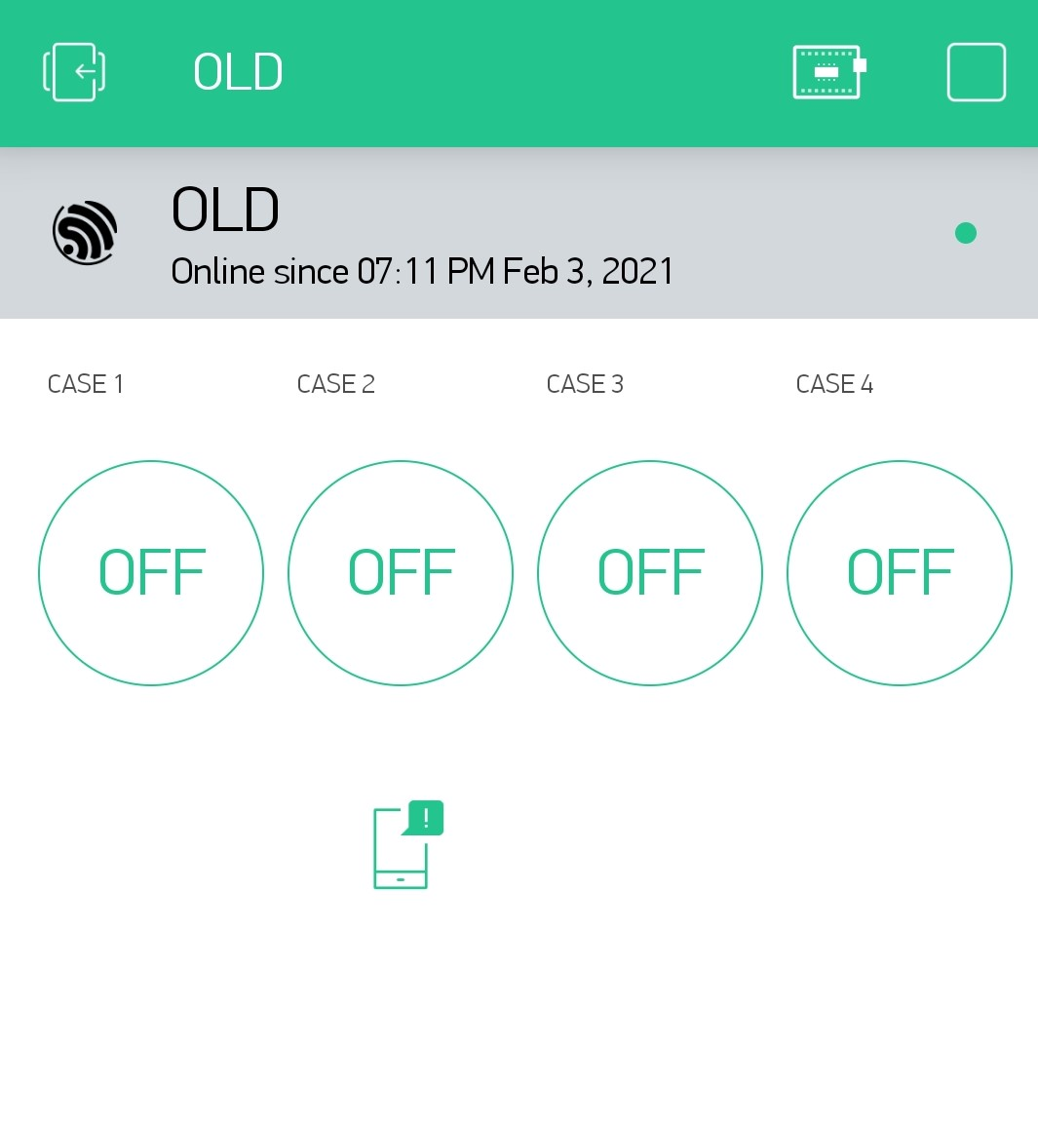

**GOOGLE ASSISTANT setup**

* To control nodemcu with Google assistant we need to integrate BLYNK with GOOGLE ASSISTANT by using a third party platform such as IFTTT, Zapier, etc
* Now in this project we are going to use IFTTT to integrate BLYNK with GOOGLE ASSISTANT.
* Now create a account in IFTTT platform by using the following link(This mail will be further used to login into the google assistant in your mobile). <https://ifttt.com/join>
* Click on create to create a new applet.

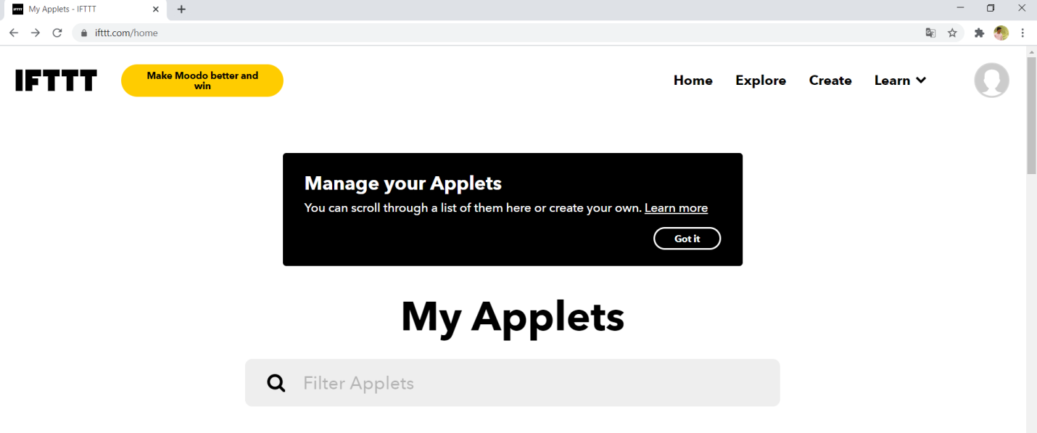

* Click on the “IF THIS ” and search for Google Assistant in the search bar.

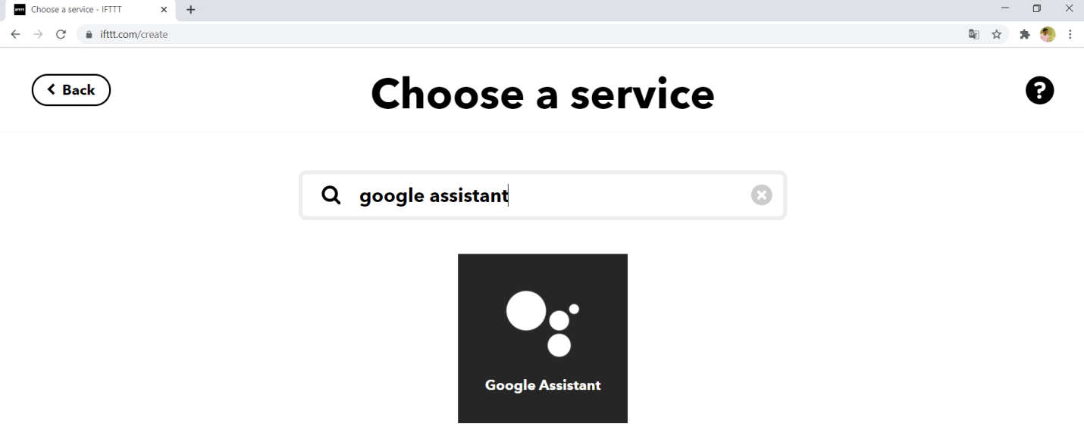

* Click on the Google assistant and select the option “SAY A SIMPLE PHRASE ”

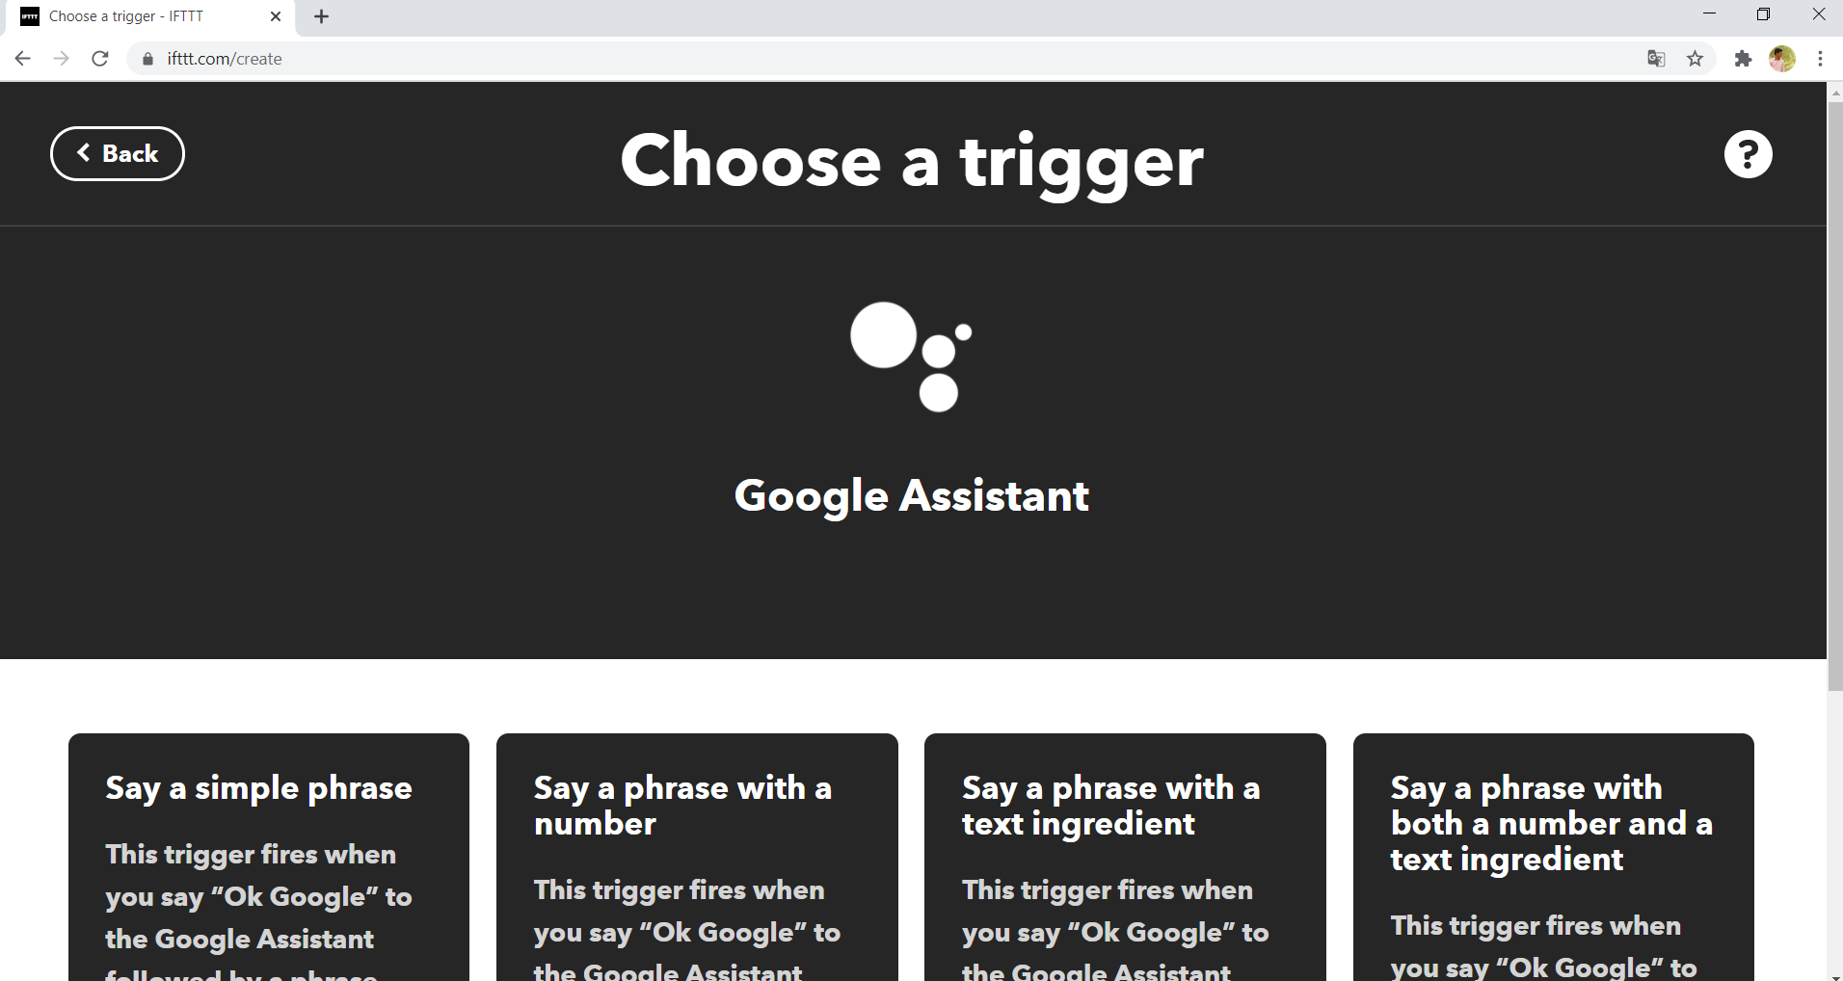

* Add the commands for which Google should turn on / turn off the light and click on create trigger.

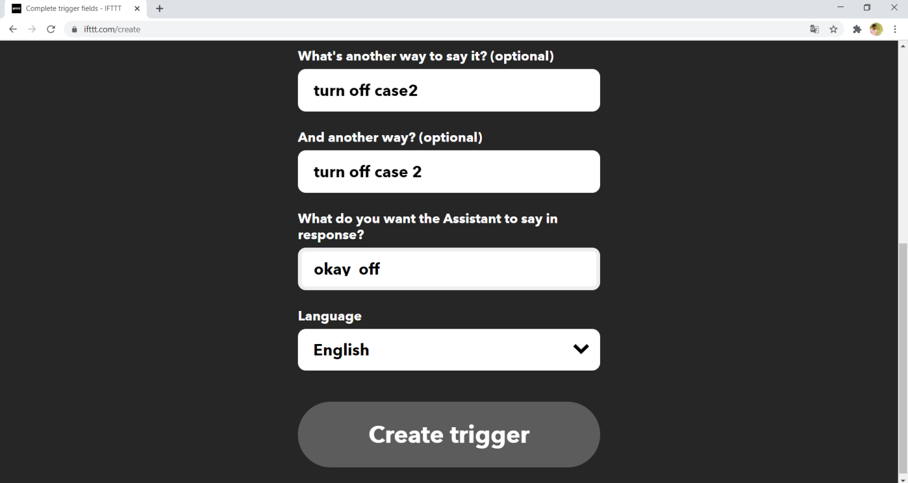

* After clicking the create trigger button it will redirect to following page and in that page click on “THEN THAT”.

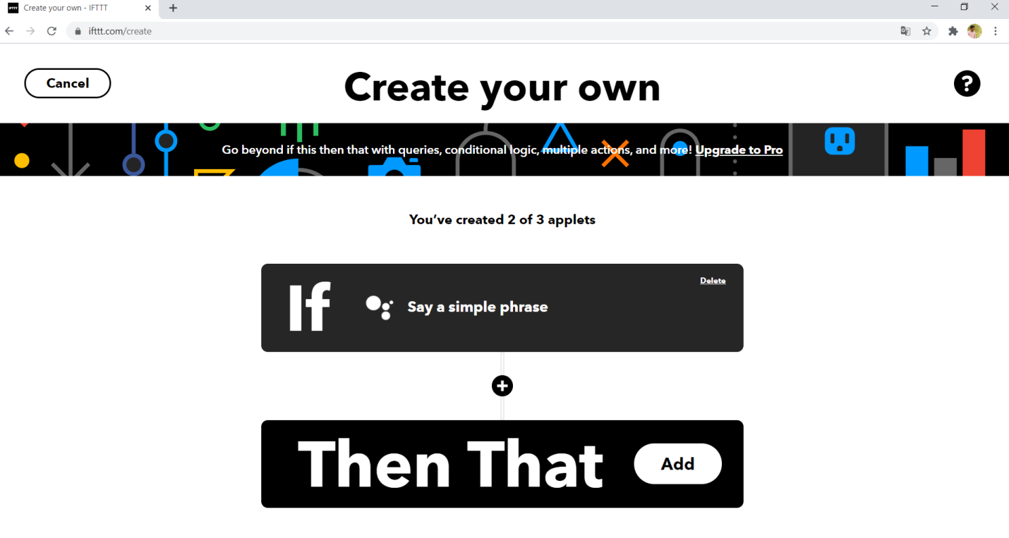

* Search for web hooks in that page and click on it.

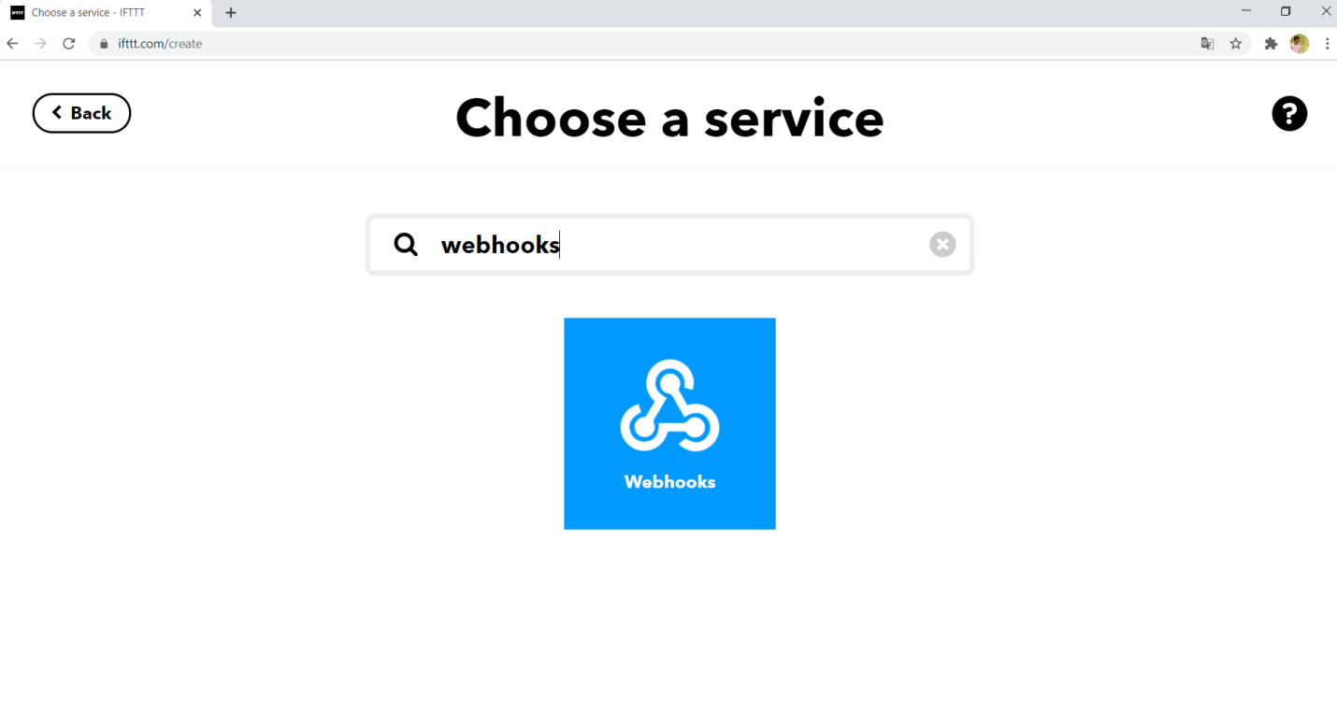

* After clicking on web hooks it will redirect to the following webpage.

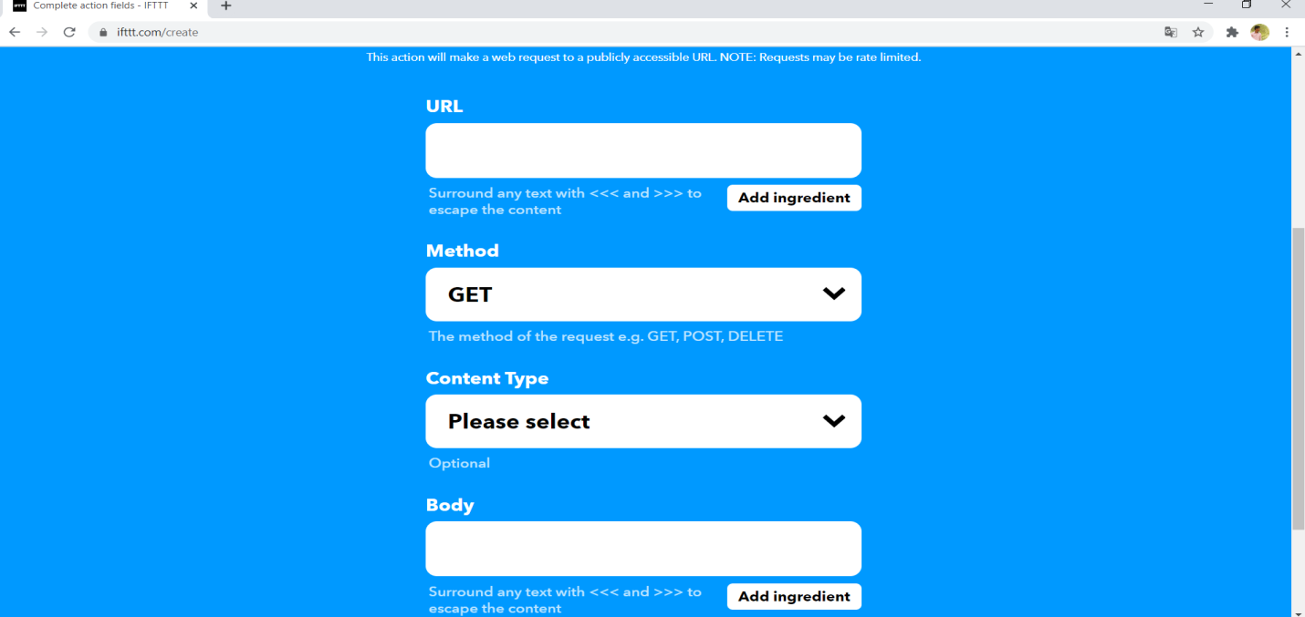

* Fill the page with the following details.
* URL : <http://188.166.206.43/BLYNKAPP_AUTH/update/PIN>
* Example : <http://188.166.206.43/JV40IBwZj3rvC-T-41Qkgkl4mpWmfR0S/update/v1>
* METHOD : PUT
* CONTENT TYPE :application/ json
* BODY : [“1”] 🡪 ON
* :[“0”]🡪 OFF
* After filling the data in above manner click on create action to activate the Google command.

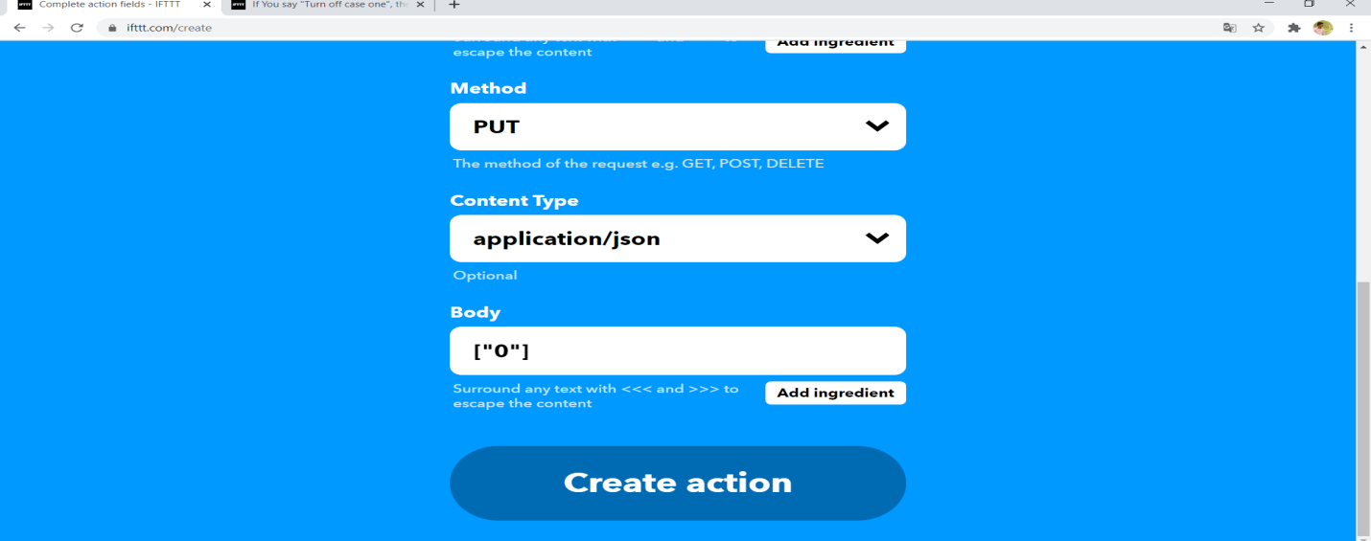

* After clicking on the create action it will redirect to the following webpage.

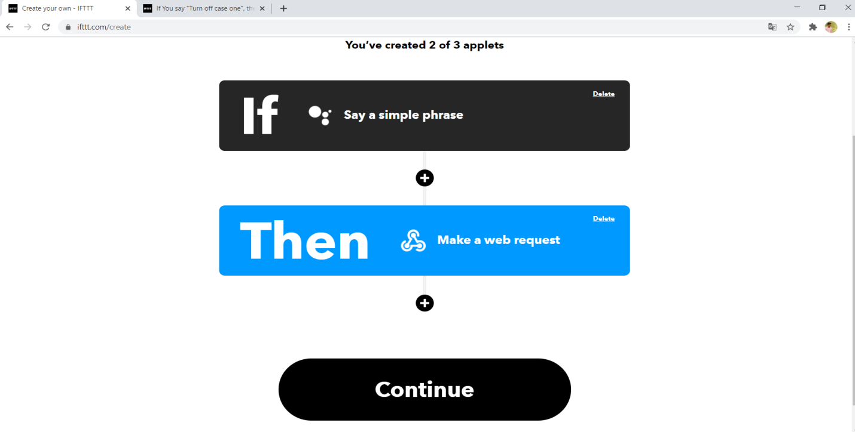

* Click on the continue button and then click on finish button to activate your Google voice command.

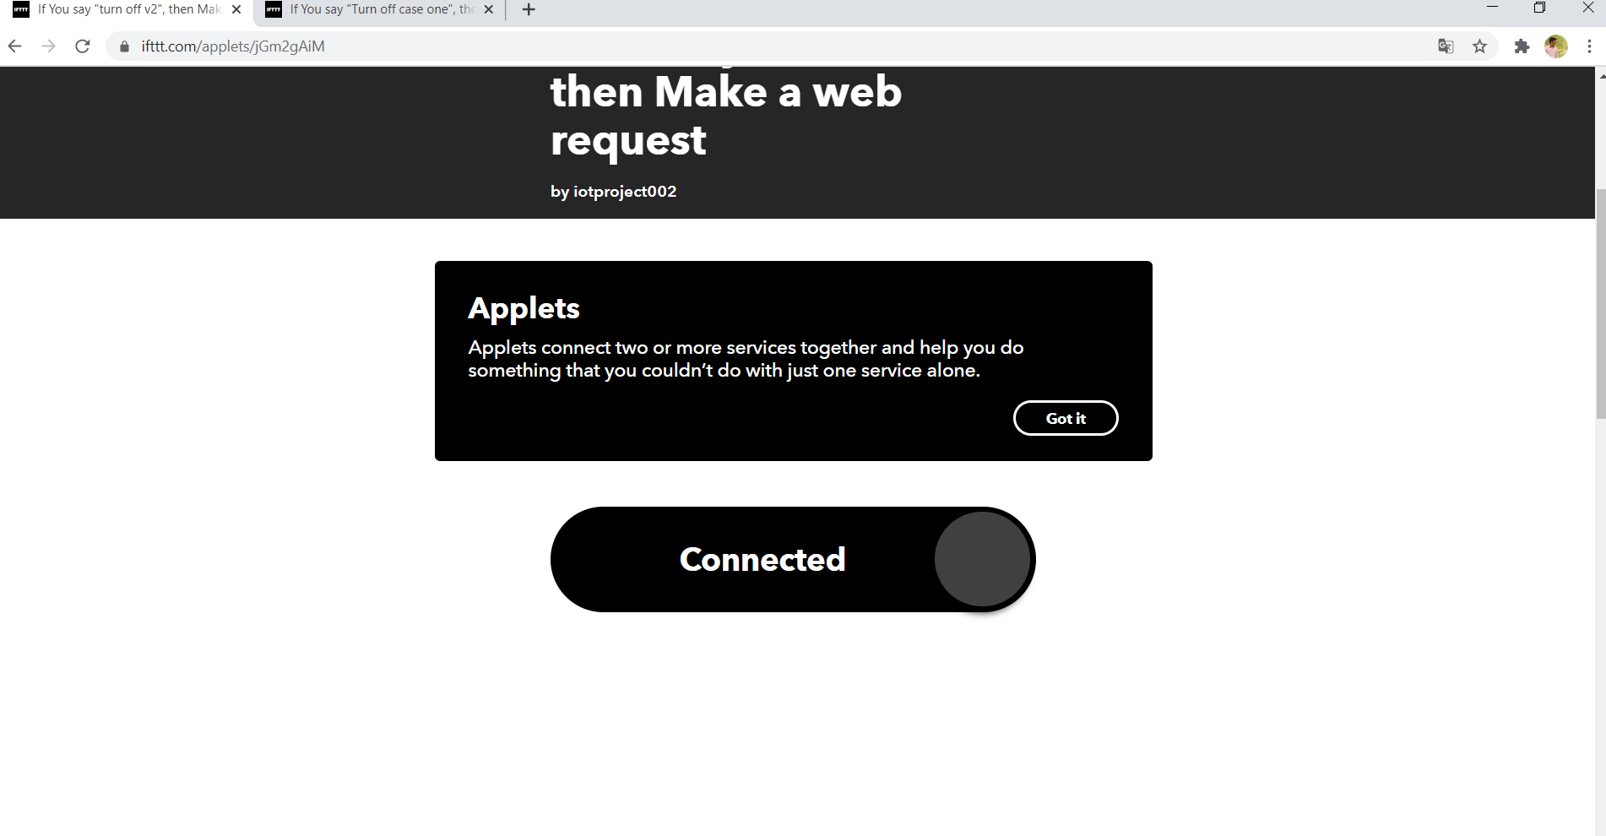

* From these now you created a command for only one operation over one button
* Now repeat the above steps to get create control over all buttons from Google assistant
* Now login to Google assistant with the mail that you have logged in the IFTTT account to use voice command.

**Conclusion**

**N**ow you can control the electronic appliances with Blynk app , Google assistant and with manual switches with real time feedback. With this type of works we can make a complete smart home, we can include TV, fridge, etc. With these types of techniques we can bring all the components over the internet. We are sure that the future generations will use these types of techniques to make their life more comfortable.

We can extend this project in various fields such as in industries, automobiles in agriculture purpose and as a security device, for protecting natural environment etc. Depending on our needs we can modify the project and make things easier to control.

References:

* <https://www.arduino.cc/en/donate/>
* https://robu.in/product/5v-4-channel-relay-module/
* <https://www.youtube.com/watch?v=Jc6Jet1Yqsk>
* <https://iotcircuithub.com/nodemcu-esp8266-blynk-home-automation/>
* <https://www.arduino.cc/en/software>
* <https://create.arduino.cc/projecthub/Raushancpr/arduino-with-ir-sensor-1579b6>
* <http://kth.diva-portal.org/smash/get/diva2:679674/FULLTEXT01.pdf>
* <https://randomnerdtutorials.com/how-to-install-esp8266-board-arduino-ide/>
* [https://components101.com/development-boards/nodemcu-esp8266-pinout-features-and-datasheet#:~:text=The%20NodeMCU%20ESP8266%20development%20board,to%20store%20data%20and%20programs](https://components101.com/development-boards/nodemcu-esp8266-pinout-features-and-datasheet).

Thank you